Hospital Smart Queue Management System
UNIVERSITY OF INFORMATION TECHNOLOGY
SEPTEMBER 2026

Course Name: CST-6108 Enterprise Applications Development using Java
Project Title: Hospital Smart Queue Management System
Group Members
1. Mg La Yaung Htut
Student ID: TNT-2384
Email: layaunghtut@uit.edu.mm
2. Ma Hsu Shoon Wutyi
Student ID: TNT-2346
Email: hswuttye@uit.edu.mm
3. Ma Noo Noo Aung
Student ID: TNT-2357
Email: nonoaung@uit.edu.mm
4. Ma Ei Pone Chit
Student ID: TNT-2357
Email: eiponechit@uit.edu.mm
5. Ma Phoo Thet Ngone
Student ID: TNT-2348
Email: phuthetngone@uit.edu.mm
Supervisor: Dr. Daw Ei Moh Moh Aung
Department: Faculty of Computer Science
Submission Date: September 2026

Contents
Right-click here and choose “Update Field” (or press F9) to generate the table of contents.

1. Introduction

1.1 Overview
The Hospital Smart Queue System is a web-based application designed to improve the management of patients, doctors, appointments, and hospital queues. In many hospitals, patients have to wait for a long time and staff members need to manually manage queues and appointments. This can cause confusion, delays, and inefficient use of hospital resources.
The proposed system provides a centralized platform where hospital staff can manage patient information, doctor information, departments, appointments, emergency cases, and patient queues. Patients can be registered and assigned to appropriate doctors, while staff can monitor the queue and update its status.
The system is developed using Java Spring Boot, MySQL, HTML/CSS, and related web technologies. The application follows a database-driven architecture so that information can be stored and retrieved efficiently.

1.2 Project Scope
The scope of the Hospital Smart Queue System covers user account management, patient registration and management, doctor registration and management, and hospital department management. It also covers appointment management, queue number generation and management, emergency case management, and consultation and diagnosis records, along with staff management and queue status monitoring. Access throughout the system is role-based, with separate permissions for administrators, doctors, staff, and patients.
The system is mainly intended for use within a hospital environment. It focuses on improving the organization of patient queues and reducing unnecessary waiting and manual work.

1.3 Objectives
The main objective of the project is to develop a computerized hospital queue management system that reduces patient waiting time and queue confusion while providing an organized method for managing appointments. The system is intended to let hospital staff manage patients and doctors efficiently, provide emergency priority handling, and store hospital information in a centralized database, so that communication between patients, doctors, and hospital staff improves.
Beyond these core goals, the project also aims to provide a simple and user-friendly interface, reduce errors caused by manual queue management, and lay a foundation that future hospital management features can build on.

2. Project Planning and Requirement Analysis

2.1 Functional vs. Non-Functional Requirements
Requirement analysis for the Hospital Smart Queue System distinguishes between functional requirements, which describe what the system must do, and non-functional requirements, which describe how well the system must do it. Both are organized below by module and by quality attribute respectively.

2.1.1 Functional Requirements
The functional requirements describe what the system should be able to do.

User Management
The system should allow administrators to create user accounts, manage usernames and passwords, and assign user roles, covering administrator, doctor, staff, and patient accounts alike.

Patient Management
Staff should be able to register new patients, view and update their information, search for a patient by name or other details, and associate each patient with the appointments and queues they are part of.

Doctor Management
Administrators or authorized staff should be able to register doctors, assign them to departments, and record their specializations, contact information, and room numbers, as well as activate or deactivate a doctor's account when needed.

Department Management
The system should maintain the hospital's departments, including Cardiology, Dental, Emergency, Neurology, Pediatrics, Dermatology, Orthopedics, and General Medicine.

Appointment Management
Staff should be able to create appointments, assign patients to doctors, set appointment dates and times, and view or update appointment status as a visit progresses.

Queue Management
The system should create queue entries and generate queue numbers, associating each entry with the relevant patient and doctor. It should also let staff set queue priority and update queue status, giving emergency patients higher priority than routine cases.

Emergency Management
Staff should be able to record emergency cases, capturing the patient involved, the staff member handling the case, the reason for the emergency, and its current status.

Consultation Management
Doctors should be able to record consultation details against a queue entry, including the doctor involved, the diagnosis, and any consultation notes.

2.1.2 Non-Functional Requirements
The system should also satisfy several non-functional requirements that describe the quality attributes it must exhibit.

Performance
The system should respond to normal user requests quickly and efficiently.

Security
User information and passwords should be protected, with access to system functions depending on the user's role.

Reliability
The system should store information consistently and reduce errors caused by manual record keeping.

Usability
The interface should be simple enough for hospital staff to use without extensive technical knowledge.

Maintainability
The application should be organized into separate components, such as models, repositories, services, and controllers, so that future developers can maintain and extend it.

Scalability
The system should be designed so that additional features, users, doctors, departments, and hospital branches can be added in the future.

2.2 Creating Use Cases and User Stories

Administrator
An administrator can log into the system, manage users, doctors, and departments, view hospital information, and manage overall system settings.
User Story: As an administrator, I want to manage users and doctors so that the hospital system contains accurate information.

Doctor
A doctor can log into the system, view assigned appointments and the patients currently in the queue, look up patient information, and record diagnoses and consultation notes as consultations are completed.
User Story: As a doctor, I want to see my patient queue so that I can treat patients in the correct order.

Staff
Staff members can register patients, create appointments, manage queues, handle emergency cases, update appointment status, and monitor patients who are waiting for consultation.
User Story: As a staff member, I want to manage the patient queue so that patients can be served efficiently.

Patient
A patient can log into the system to view their appointment and queue information and check their current queue status.
User Story: As a patient, I want to know my queue number and status so that I understand when I may be called for consultation.

3. System Design and Architecture

3.1 System Architecture Design
The Hospital Smart Queue System uses a layered application architecture. The main layers are:

Presentation Layer
This layer provides the user interface through web pages. Users interact with the system through their browser.

Controller Layer
The controller receives requests from users and determines which operation should be performed.

Service Layer
The service layer contains the main business logic of the application. It processes operations such as creating appointments, managing queues, and handling consultations.

Repository Layer
The repository layer communicates with the database and performs operations such as inserting, updating, deleting, and retrieving records.

Database Layer
MySQL is used to store system data.
The basic flow is:
User
↓
Web Browser
↓
Controller
↓
Service
↓
Repository
↓
MySQL Database

This architecture separates different responsibilities and makes the application easier to maintain.

3.2 Database Design: ER Diagrams
The database contains several related entities. The main tables include users, departments, doctors, staff, patients, appointments, queue, emergency, and consultation.
The major relationships are:
Users
+-- Doctors
+-- Staff
+-- Patients
Departments
|
+-- Doctors
Patients
|
+-- Appointments
+-- Queue
+-- Emergency
Doctors
|
+-- Appointments
+-- Queue
+-- Consultation
Appointments
|
+-- Queue
Queue
|
+-- Consultation
For example, a patient can have multiple appointments. An appointment is associated with a doctor, and an appointment can result in a queue entry. A queue entry can then be associated with a consultation.
The database uses primary keys to uniquely identify records and foreign keys to establish relationships between tables.

4. Development Environment Setup

4.1 Tools and Technologies
The following technologies are used to develop the system:
Technology | Purpose
Java | Main programming language
Spring Boot | Backend application framework
Spring Data JPA | Database access
Hibernate | ORM framework
MySQL | Database management
Maven | Project and dependency management
HTML | Web page structure
CSS | Web page styling
JavaScript | Client-side functionality
IntelliJ IDEA | Development environment
XAMPP / phpMyAdmin | MySQL database administration
Firefox / Chrome | Application testing

4.2 Development Environment
The project is developed using IntelliJ IDEA. The backend is created using Spring Boot and managed using Maven. MySQL is used as the database server, while phpMyAdmin can be used to view and manage database records during development.
The project follows a structure similar to:
HospitalSmartQueueSystem
|
+-- src
| +-- main
| | +-- java
| | | +-- com.hospitalqueue
| | | +-- controller
| | | +-- model
| | | +-- repository
| | | +-- service
| | |
| | +-- resources
| | +-- templates
| | +-- static
| | +-- application.properties
| |
| +-- test
|
+-- pom.xml
+-- mvnw

4.3 Coding Standards
The project follows a consistent set of coding practices: meaningful class and variable names, standard Java naming conventions, and a clear separation of responsibilities into different packages. Entity classes represent database tables, repositories handle database operations, services contain business logic, and controllers handle incoming web requests. Code duplication is avoided where possible, comments are added where they improve understanding, and indentation and formatting are kept consistent throughout.

5. Screen Layout and Design
The system provides different screens depending on the user's role.

Login Screen
The login page allows users to enter their username and password. After successful authentication, the user is directed to the appropriate dashboard based on their role.

Administrator Dashboard
The administrator dashboard provides access to user management, doctor management, staff management, patient management, department management, and appointment management, giving administrators a single place to oversee the whole system.

Staff Dashboard
The staff dashboard focuses on daily hospital operations, including patient registration, appointment management, queue management, emergency cases, and patient information.

Doctor Dashboard
The doctor dashboard shows today's appointments and the current queue, along with patient information, consultation, diagnosis, and consultation notes.

Patient Dashboard
The patient dashboard can display personal information, appointment information, and the patient's queue number and status.

Queue Screen
The queue screen should clearly display information such as:
Queue Number | Patient | Doctor | Priority | Status
A001 | Mg Mg | Dr. Su Su | NORMAL | WAITING
A002 | Ma Ma | Dr. Su Su | NORMAL | WAITING
B001 | Ko Ko | Dr. James | EMERGENCY | WAITING

Emergency cases can be visually prioritized so staff and doctors can identify them easily.

6. Conclusion and Reflection

6.1 Project Summary
The Hospital Smart Queue System was developed to improve the management of patients and hospital queues. The system combines patient management, doctor management, appointments, emergency cases, queues, and consultations into one centralized application.
The use of a relational database allows information to be stored systematically and relationships between patients, doctors, appointments, queues, and consultations to be maintained.
The system also provides a foundation for reducing manual queue management and improving hospital workflow.

6.2 Challenges and Solutions
During development, several challenges were encountered.

Database Relationships
Managing relationships between multiple tables was challenging because foreign keys must reference valid records. This was solved by inserting related data in the correct order. For example, users and doctors need to exist before dependent records such as appointments and queues can be created.

Duplicate Data
Duplicate values occurred when unique fields such as usernames or queue numbers were inserted more than once. This was handled by checking existing records before inserting new data and using unique identifiers appropriately.

Application Configuration
Connecting the Spring Boot application to MySQL required correct database configuration and compatible entity mappings. The database connection and JPA configuration were tested during development.

Queue Management
The queue system required relationships between appointments, patients, and doctors. The queue table was therefore designed to reference these records using foreign keys.

6.3 Lessons Learned
Through this project, the team developed several important skills, including Java programming, Spring Boot development, database design, SQL and MySQL, and working with JPA and Hibernate. Building the application also strengthened the team's understanding of REST and web application concepts, HTML and CSS, software architecture, debugging, foreign-key relationship management, and project planning.
The project also demonstrated the importance of testing each part of a system before connecting all components together.

6.4 Future Enhancements
Looking ahead, the system could be extended with online patient registration and online appointment booking, along with automatic queue number generation and real-time queue updates. SMS and email notifications, together with real-time emergency alerts, would keep patients and staff better informed, and a mobile application would make the system easier to reach outside the hospital.
On the administrative side, doctor availability schedules, hospital branch management, and detailed reports and statistics would support day-to-day planning, while dashboard charts and analytics would give administrators a clearer view of overall performance. Stronger authentication and password encryption, along with support for patient medical history, would further improve the security and usefulness of the system.

7. Appendices

7.1 Screen Design
Screen designs of the implemented system are presented below.
Note: The following pages show the UI/UX design references (high-fidelity wireframes) produced during the design phase of the project. They illustrate the intended screen layout and information architecture described in Section 5; minor branding and wording differences from the deployed application may exist.
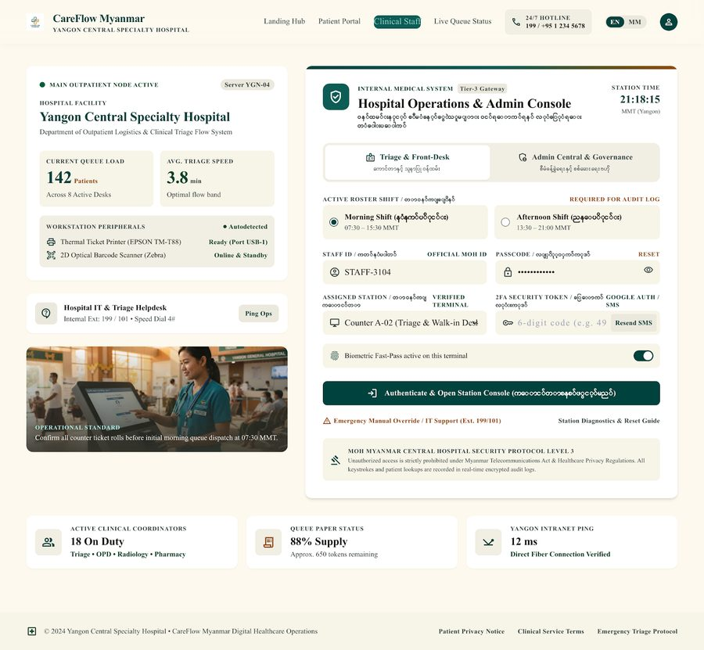
Figure 1. Figure 1: Hospital Smart Queue System — Login Page
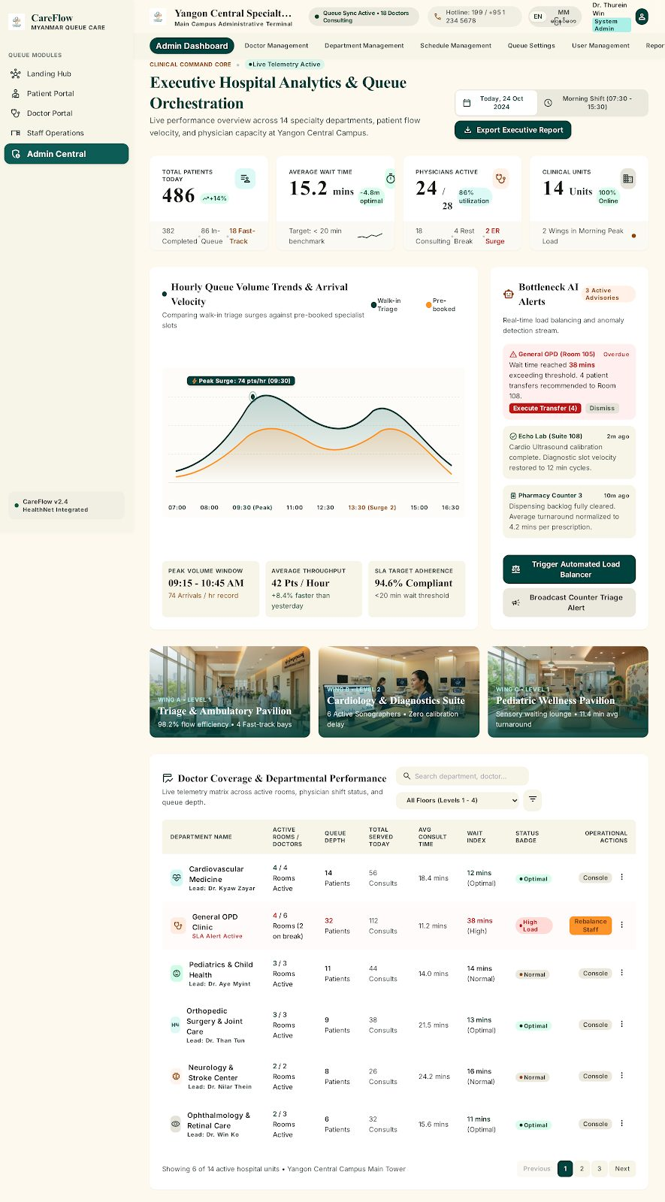
Figure 2. Figure 2: Administrator Dashboard
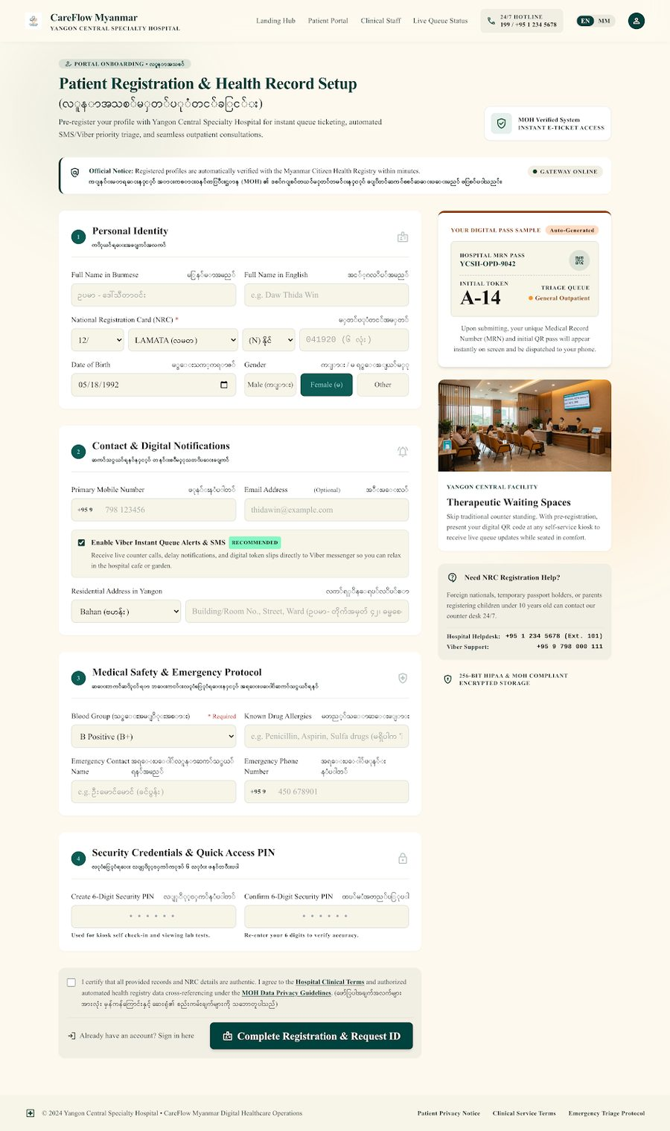
Figure 3. Figure 3: Patient Registration / Management Page
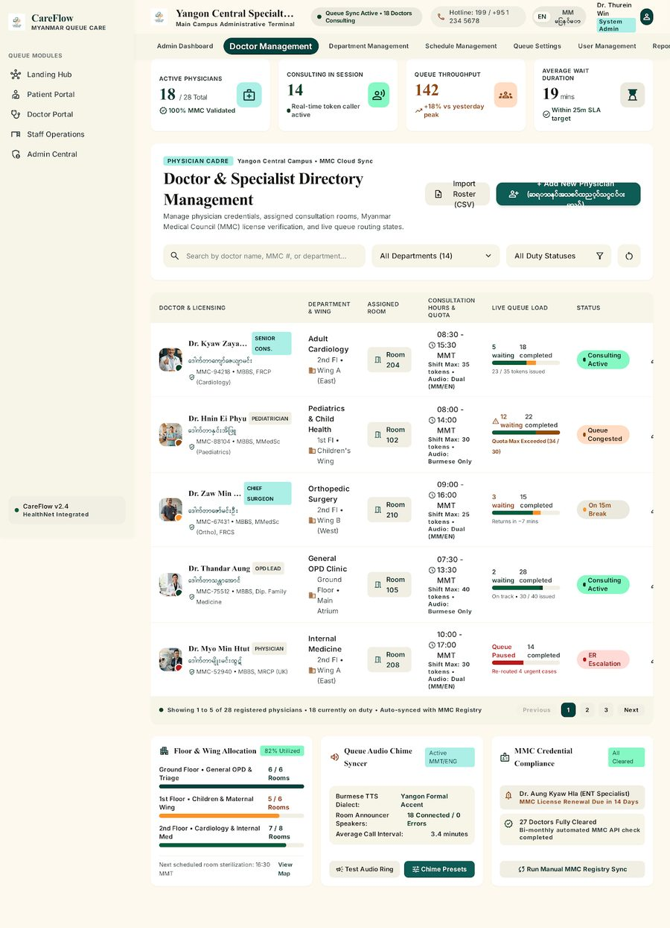
Figure 4. Figure 4: Doctor Management Page
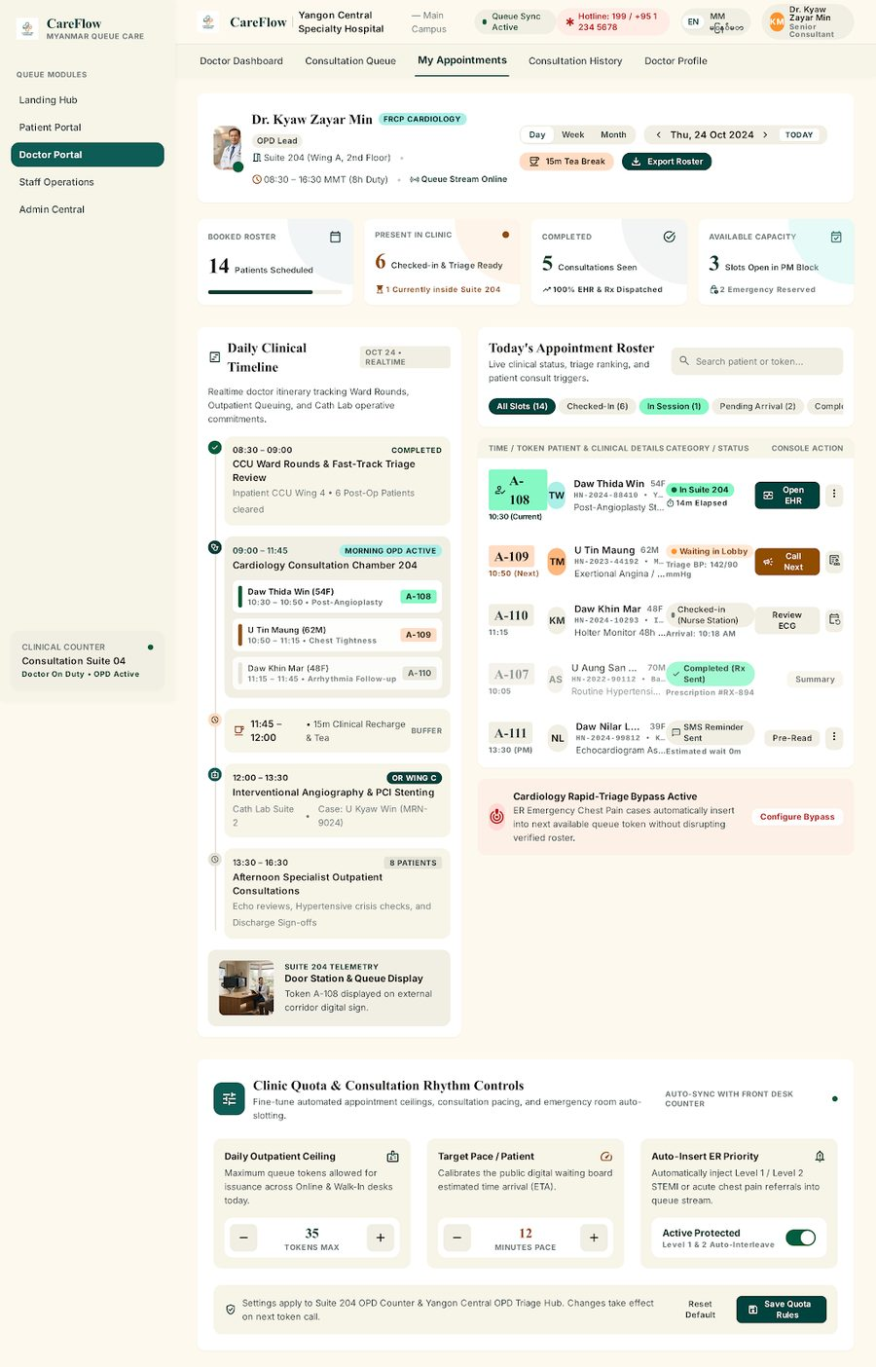
Figure 5. Figure 5: Appointment Management Page
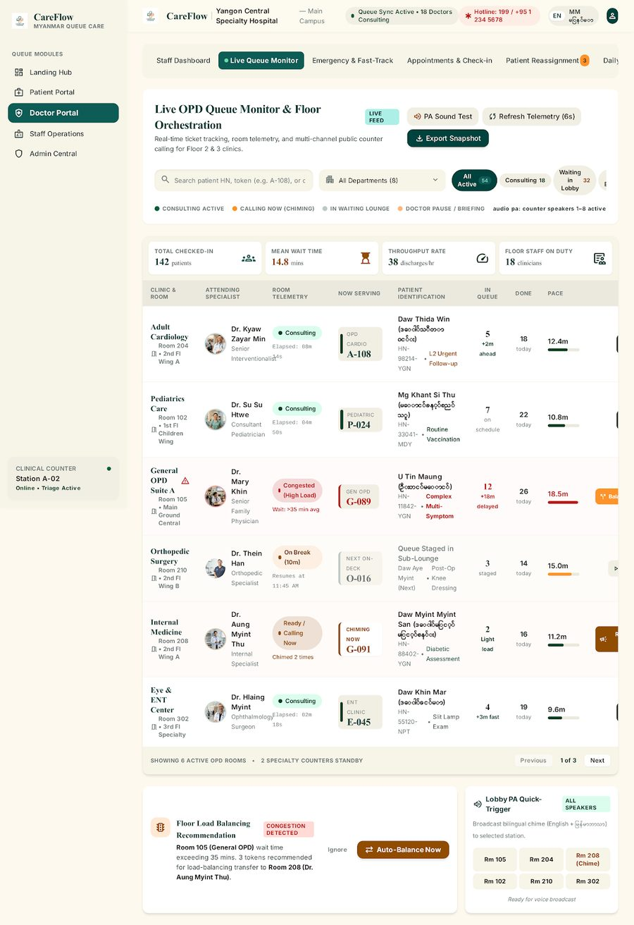
Figure 6. Figure 6: Staff Queue Management Page
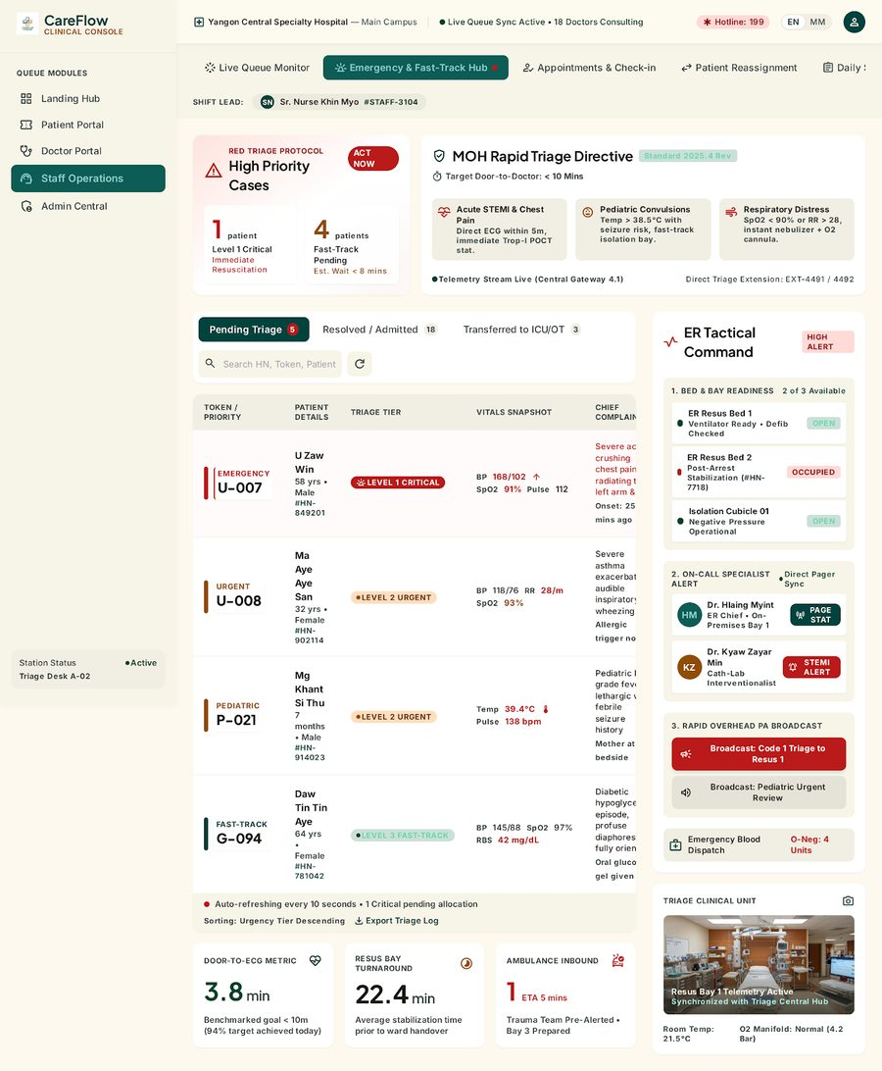
Figure 7. Figure 7: Emergency Case Management Page
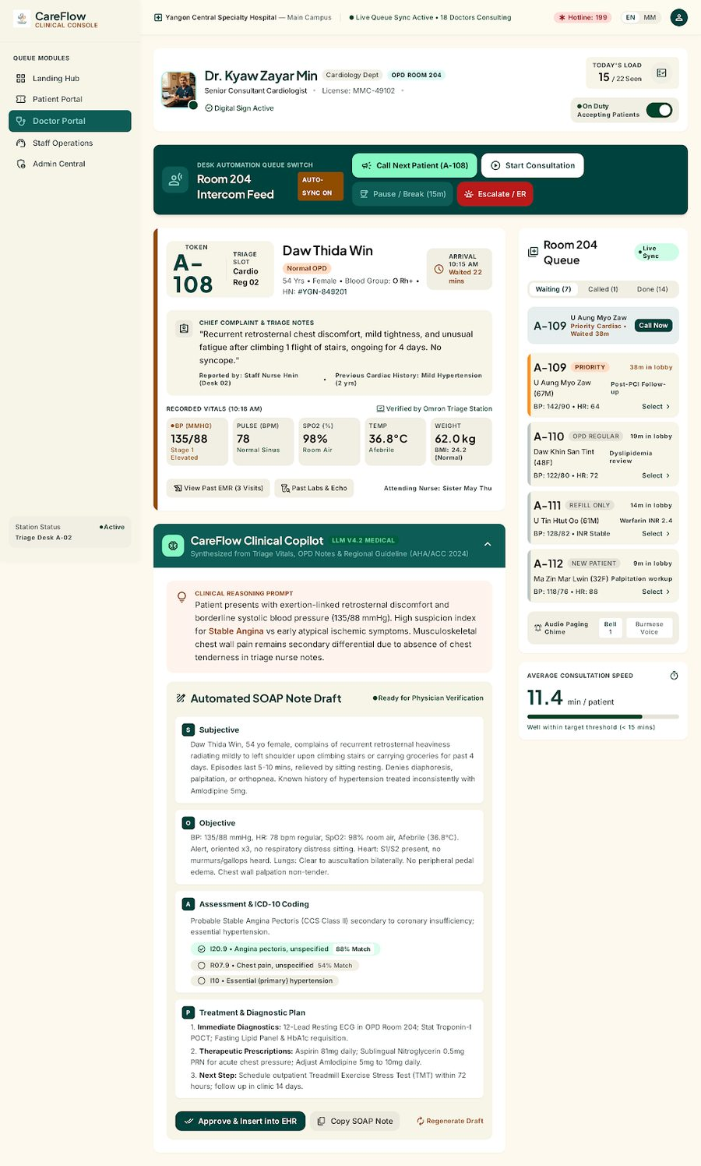
Figure 8. Figure 8: Doctor Consultation Page
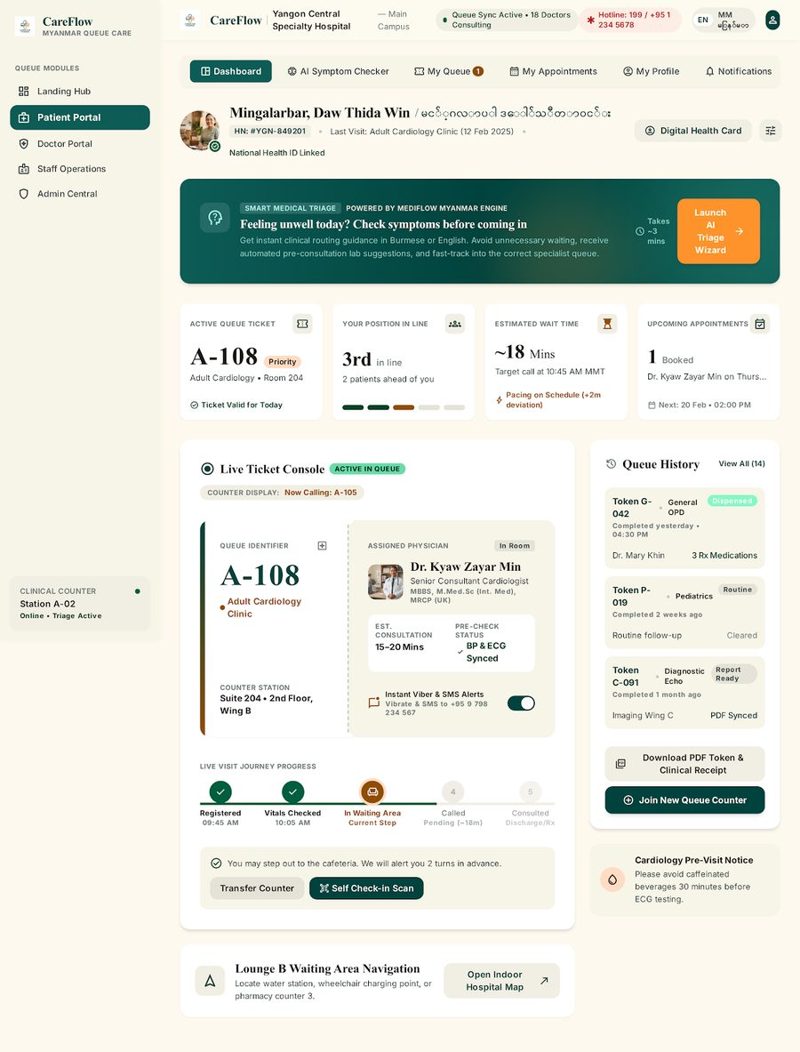
Figure 9. Figure 9: Patient Dashboard

7.2 References
[1] L. V. Green, "Queueing analysis in healthcare," in Patient Flow: Reducing Delay in Healthcare Delivery, R. W. Hall, Ed. Boston, MA: Springer, 2006, pp. 281–307.
[2] N. Gilboy, P. Tanabe, D. Travers, and A. M. Rosenau, Emergency Severity Index (ESI): A Triage Tool for Emergency Department Care, Version 4. Implementation Handbook 2012 Edition, AHRQ Pub. No. 12-0014, Rockville, MD: Agency for Healthcare Research and Quality, 2012.
[3] F. Y. Lin and H. C. Chen, "Machine learning algorithms for predicting outpatient waiting time," International Journal of Environmental Research and Public Health, vol. 17, no. 18, p. 6542, 2020.
[4] I. Mohammadi, H. Wu, A. Turkcan, T. Toscos, and B. N. Doebbeling, "Data analytics and modeling for appointment no-show in outpatient clinics," Journal of Healthcare Engineering, vol. 2018, Article ID 4187050, 2018.
[5] P. Lewis et al., "Retrieval-augmented generation for knowledge-intensive NLP tasks," in Advances in Neural Information Processing Systems (NeurIPS 2020), vol. 33, pp. 9459–9474, 2020.
[6] R. C. Martin, Clean Architecture: A Craftsman's Guide to Software Structure and Design. Boston, MA: Prentice Hall, 2017.
[7] J. Bloch, Effective Java, 3rd ed. Boston, MA: Addison-Wesley Professional, 2018.
[8] C. Walls, Spring in Action, 6th ed. Shelter Island, NY: Manning Publications, 2022.
[9] A. Silberschatz, H. F. Korth, and S. Sudarshan, Database System Concepts, 7th ed. New York: McGraw-Hill Education, 2020.
[10] R. T. Fielding, "Architectural styles and the design of network-based software architectures," Ph.D. dissertation, Department of Information and Computer Science, University of California, Irvine, CA, 2000.

